Penetration Testing Report:

General Scan information:

|  |  |  |  |
| --- | --- | --- | --- |
| Website | No. Of URL's Tested | No. Of Successful Attacks | Time Taken |
| XVWA | 117 | 1 | 200 Seconds |

Website Vulnerability Statuses:

|  |  |
| --- | --- |
| Website | Safety |
| XVWA | Website Vulnerable! |

XVWA

Date and Time of Report: 12-05-2023, 13:44:35

Types of Successful attacks: ['Error Based SQL Injection']

SQLI Strings Attempted in Total: 15317

### SQLI Strings Used:

[-] AND 1 = utl_inaddr.get_host_address ( ( SELECT DISTINCT ( table_name ) FROM ( SELECT DISTINCT ( table_name ) , ROWNUM AS LIMIT FROM sys.all_tables ) WHERE LIMIT = 5 ) ) AND 'i' = 'i

### Vulnerable Pages:

[-] http://127.0.0.1:1234/xvwa/vulnerabilities/sqli/

Vulnerability Statistics:

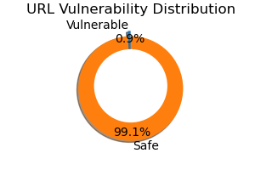

Recommendations:

SQL Injection: https://owasp.org/www-community/attacks/SQL_Injection